SIMATS ENGINEERING (SAVEETHA SCHOOL OF ENGINEERING)
Department of Computer Science and Engineering

ASSESSMENT TOOL 2 – Pseudocode Writing Task

Course Code: | CSA06 | Course Title: | Design and Analysis of Algorithms
CO Assessed: | CO5 – Naturalization (BL5, BL6) | Assessment: | Assessment Tool 2 –  Pseudocode Writing Task
Weightage: | 30% of CIA | Total Marks: | 100
CO5 Statement: | Analyze computational problems using backtracking techniques and complexity classes such as P, NP, NP-Hard, and NP-Complete for combinatorial problem solving.
Student Name: | V SANJANA | Reg. No.: | 192571005
Section / Batch: | 2025 | Date: | 25-08-2026

Instructions to Students
- Answer the following question with proper pseudocode and logical explanation.
- Clearly specify the algorithmic approach and complexity class wherever applicable.
- Use proper asymptotic notation (Big-O, Big-Θ, Big-Ω) for complexity analysis.
- Include state-space representation, recursion steps, and pruning conditions in backtracking problems.
- Neat presentation and step-by-step justification are mandatory.

Question Type | Focus Area | Questions
Pseudocode Writing Task | Analyze combinatorial problems using backtracking and complexity classes such as P, NP, NP-Hard, and NP-Complete. | Q1

SECTION A – Pseudocode Writing Task

Code of Conduct
I _V SANJANA(192571005)_ (certify that this submission is my original work and that I have adhered to the guidelines specified for this assessment. I understand that any violation of academic integrity rules will result in disciplinary action.
Signature of the Student: _________________________

RUBRICS FOR CALCULATION

Criteria | Weight age | Level 4 –  Exemplary | Level 3 –  Proficient | Level 2 –  Developing | Level 1 –  Beginning
Problem  Understanding | 20% | Identifies all inputs, outputs, constraints accurately | Minor missing elements | Partial understanding | Incorrect interpretation
Algorithm Design | 30% | Complete, correct, and logically sound solution | Minor logical gaps | Partially correct logic | Incorrect approach
Use of Control Structures | 20% | Efficient and appropriate use of loops, conditions, functions/modules | Minor inefficiencies | Limited or basic usage | Incorrect or missing constructs
Pseudocode  Structure | 10% | Well-structured, clear, consistent format, easy to follow | Mostly clear with minor issues | Difficult to follow in parts | Poorly structured and unclear
Completen ess | 20% | Handles all cases; optimized approach | Handles most cases; reasonable efficiency | Handles basic cases only | Incomplete or inefficient
Marks Evaluation:

Faculty In-charge | Course Coordinator | Head of Department
Name: | Name: | Name:
Signature: _______________ | Signature: _______________ | Signature: _______________
Date: ___________________ | Date: ___________________ | Date: ___________________

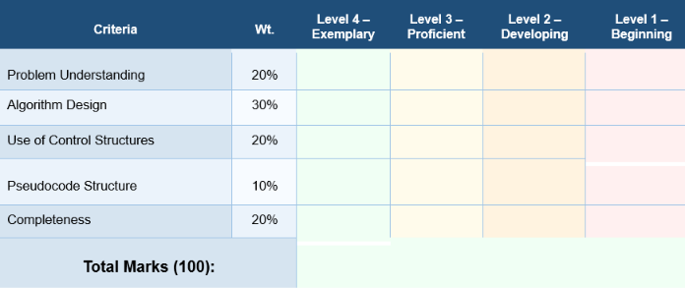

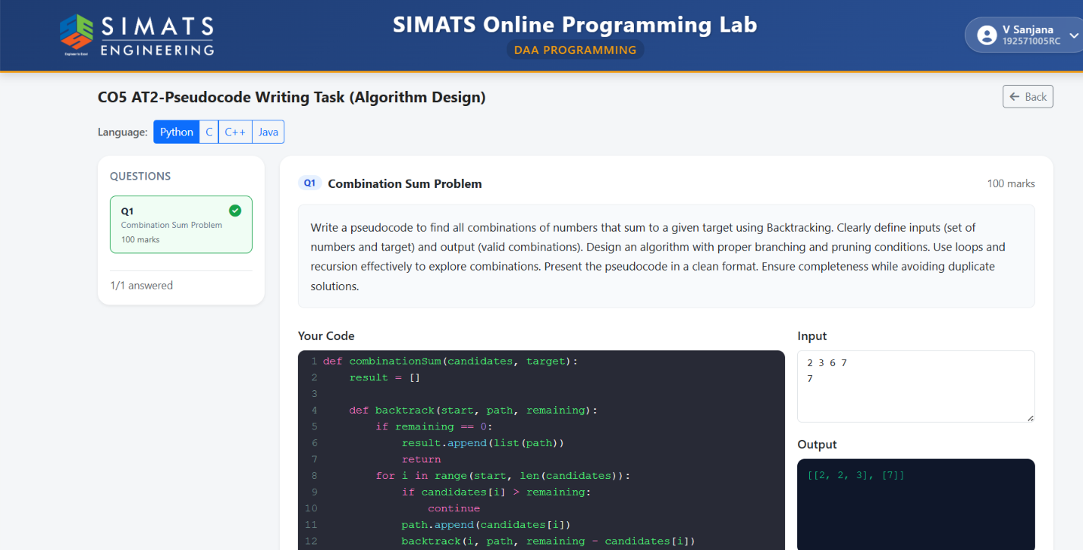

Time Complexity
The Combination Sum Problem uses a backtracking approach to explore different possible combinations of the given candidate numbers. At every recursive call, the algorithm decides which candidate should be included in the current combination. Since the same candidate can be selected multiple times, the number of recursive calls mainly depends on the target value and the smallest candidate value.
Let:
- N = number of candidate elements
- T = target value
- M = minimum candidate value
The maximum depth of the recursion tree can be approximately:
T / M
This occurs when the smallest candidate is repeatedly selected until the target becomes zero.
At each level of recursion, the algorithm may examine up to N candidates. Therefore, an approximate worst-case time complexity can be expressed as:
O(N^(T/M))
This represents the large number of possible branches that may have to be explored before finding all valid combinations.
For example, if the candidates are:
{2, 3, 6, 7} and Target = 7
the algorithm explores combinations beginning with 2, 3, 6, and 7. Some branches continue recursively, while others are terminated when their sum exceeds the target.
The actual execution time is usually much lower because pruning eliminates unnecessary branches. Since the candidate array is sorted, whenever:
candidate[i] > remaining target
the algorithm immediately stops exploring that branch. All larger candidates can also be ignored. This significantly reduces the number of recursive calls.
Hence, although the theoretical worst-case complexity is exponential, backtracking with proper pruning performs efficiently for moderate input sizes.
Factors Affecting Time Complexity
- Number of candidate values.
- Size of the target value.
- Smallest value present in the candidate set.

